Why Paying Out-of-Pocket for Sleep Apnea Treatment Could Save You Thousands

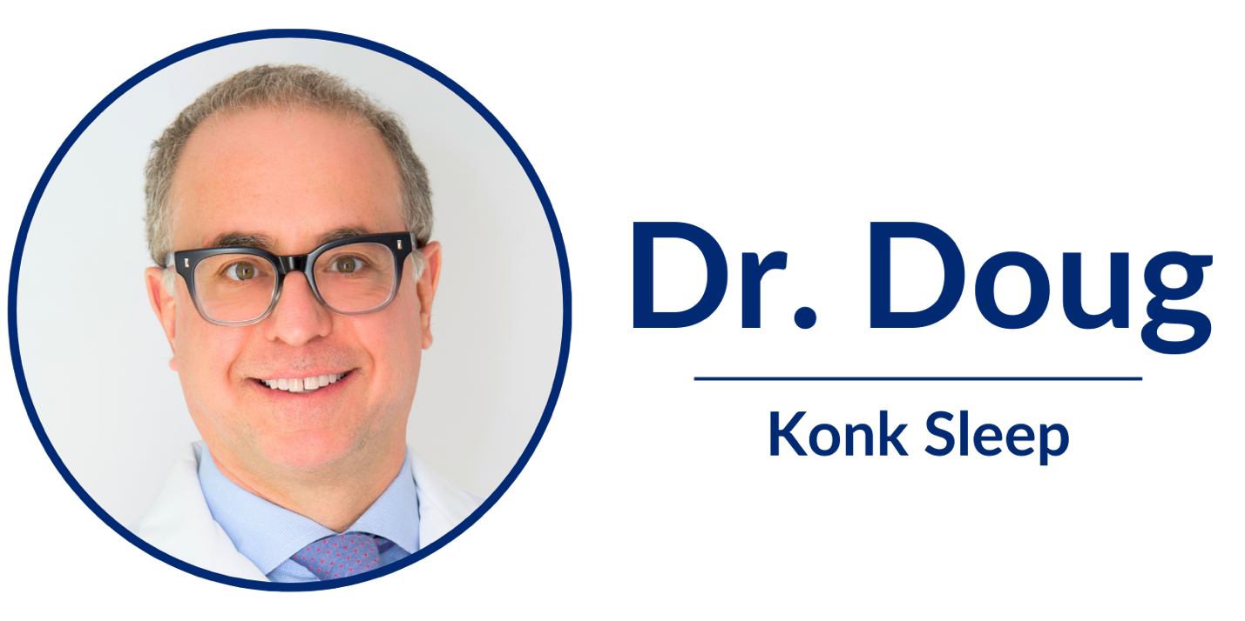
According to the American Academy of Sleep Medicine (AASM), the average person with obstructive sleep apnea (OSA) spends $2,105 per year on testing, medical appointments, and treatment devices, after paying for health insurance premiums. For many patients, the out-of-pocket costs of co-pays, deductibles, and coinsurance quickly add up, making the process lengthy, expensive, and frustrating. But what if there was a more affordable way to get the treatment you need?
The traditional insurance route for diagnosing and treating OSA can involve multiple appointments, overnight sleep studies, and high costs, especially if your insurance requires prior authorizations and imposes high deductibles. In contrast, self-paying through an open market solution may significantly reduce expenses and streamline the process. Here’s why opting out of the insurance-based model could be the key to getting the right treatment for a fraction of the cost.

The Costly Path of Traditional Insurance Coverage
The initial path to diagnosis usually starts with a visit to your primary care provider, followed by a referral to a sleep specialist, multiple tests, and then a consultation to interpret your results. These initial appointments alone can easily exceed $500 in co-pays and deductibles.
Once diagnosed, you may be directed to complete an overnight sleep study, which can cost anywhere from $3,000 to $6,000, depending on your insurance plan. Even with coinsurance, you could still be responsible for 20% or more of these costs, adding hundreds or thousands of dollars to your final bill. All this, and you haven’t even started treatment yet.

Hidden Costs of CPAP Machines Through Insurance
Once diagnosed, most patients need a positive airway pressure (PAP) machine to manage their sleep apnea. But even with insurance, getting the machine is not straightforward. Many insurance companies require patients to rent the device for up to a year, monitoring usage to determine if you can keep it.
This rental typically costs around $70 per month, adding up to $840 in rental fees alone. By the time you factor in the cost of the machine, the mask, and replacement parts, your first year can easily surpass the $2,105 average, making your “covered” care far more expensive than expected.

Why an Open Market Solution Makes Sense
In an open market model, you bypass the red tape and high costs associated with insurance. Instead of paying for multiple visits, complicated authorizations, and ongoing rental fees, you could bundle your diagnostics, clinical support, and treatment into a single, upfront payment.
Open market solutions streamline the process by gathering your health data, confirming your diagnosis within days, and shipping your APAP directly to your home, often for less than $1,200. This includes live support from respiratory therapists and ongoing consultations to ensure successful treatment.

Get the Sleep You Deserve With Konk Sleep
If navigating the insurance system is delaying your treatment or adding stress to your health journey, it’s time to explore a simpler, more affordable solution. By opting for an open market approach, you can save thousands and get started on effective sleep apnea treatment quickly. Visit Konk Sleep to explore your options and take the first step toward better sleep and improved health, all without leaving your home.
Start Your Digital Clinical Interview


